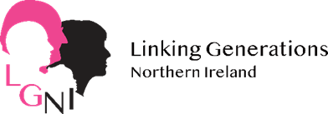
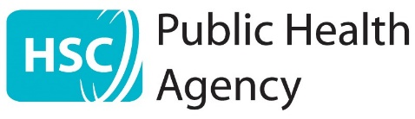

All Ages April Grant 2022
Application Pack

A Small Grants Programme to bring generations together
to build Age-Friendly communities and celebrate ALL AGES APRIL 2022

Please complete this application form and return to:
Email: lynn.heatley@bjf.org.uk
by
Friday 11th March @ 12.00 P.M.
Grant per group: £150
If you have queries, please contact:
Email lynn.heatley@bjf.org.uk
A call can be organised to discuss any queries.

Deadline Friday 11th March at 12pm
Grant Amount £150 per group

Contents
Application Criteria Page 3
Application Form Page 4 to 8
Return Instructions Page 8
Contract Page 9 MUST BE COMPLETED & RETURNED
Useful Ideas and links Page 10
Global Intergenerational Week Page 10

Application to be returned to:
Email: lynn.heatley@bjf.org.uk

Application criteria
All Ages April funding aims to create connections across generations and organisations that wouldn’t normally work together. LGNI’s vision is that these connections and relationships will continue into the future.
Your activity can be a one-off event or a project delivered over a number of sessions. We hope that by taking part you will see the value of incorporating Intergenerational and Age-friendly values into your everyday practice.
Eligibility criteria
We welcome applications from all sectors: public, private and voluntary community
- Applicants must be an organisation or organised group with:
- A bank account in the name of the organisation
- Accounts that are annually audited or checked by an independent examiner
- A Safeguarding Children policy (for groups working with children under 18)
- A Safeguarding Adults at Risk policy (for groups working with adults at risk)
- A signed and dated governing document if a voluntary organisation
- Events must be in Northern Ireland
- Events must be during April 2022
- Funding is towards the cost of running activities. We do not fund capital items
- Projects must bring together at least 12 people in a way that supports the intergenerational principles and is likely to deliver wellbeing benefits to both older and younger participants
- Applicants who have had a grant from LGNI before, must have the paperwork for it up to date
Selection criteria
We use the following criteria to assess applications:
- The project follows the principles of intergenerational practice and our good practice guide. Please refer to our website for more detail: www.linkinggenerationsni.com
- For more information to support your application click:
Summary of principles of intergenerational practice:
- An effort to make good use of existing resources and partnerships
- Develop and plan activities engage older people who don’t get out much
- Applications that bring LGNI into contact with groups or communities we have not worked with before

All Age April Small Grants 2022
- Contact details

Name of group/organisation:

Council Area:

Name of contact person:

Address:

Telephone no: Mobile no:

Email address:
Does your group use social media? If yes please give Facebook / Twitter addresses below:

Facebook: Twitter:
(FYI we are Linking Generations NI on Facebook & @LinkGenNI on Twitter)

Website

- Tell us about your group e.g. what do you do? What area do you cover? Have you done activities with people of different ages before?

- Your Project Idea:
3.1 Please tell us what you plan to do for your All Ages April activity, why you think it is important to bring generations together and what the benefits will be to all involved.
Your activity can be a one-off event or a project delivered over a number of sessions, provided the activities being funded take place in April
(Please use a separate page if necessary)

3.2 Approximately how many people will be involved in your project? (There should be at least 6- 8 of each age group)

Older People:
Younger People:

3.3 This funding is for activity during April 2022 -can you confirm this timescale is possible?
YES……. NO……..
3.4 Have you any existing partnerships that would benefit from this activity? e.g. How will you recruit participants? What preparation work do you need to do?

- Organising and delivering your project
A bit about planning and resourcing your project
- What are the main benefits you hope your younger and your older participants will get from your project and why?

- If you plan to work with other groups or organisations on the project, please tell us who they are here, what their role/s will be and whether you’ve worked well with them before or you are starting a new relationship with them.

- This funding is for activity during April. Is there anything that might mean you cannot deliver in this time scale?
Can you think of a back-up plan, to be able to adapt if any issues arise?

- What, if any, items, venues etc do you need that you can supply from your own resources or partner’s resources or other funding?

- Project Costs
Successful activities will receive a grant of £150 in advance
(These grants are designed to support activities, not capital costs)

How much will the activity cost and what will you spend the money on? (Please note we would urge you to use existing resources where available)

Item / Activity | Amount needed
Total £150 | £

- Bank Details
Please give full bank account details of your organisation (please ensure these are accurate)
Bank Name: ...........................................................................................
Branch Address: ......................................................................................
Bank Account Name: .................................................................................

Sort Code:

Account Number:

- Organisation Governance Checklist
Please tick to confirm your organisation has the following governance arrangements currently in place
A signed and dated constitution or governing document ☐
A bank account in the name of your organisation ☐
Our accounts are annually audited ☐
A relevant child protection policy (for groups working with children under 18) ☐
Vulnerable adults policy where appropriate ☐

- Contract for payment of funding: between YOU and LGNI. Please read, sign and return to LGNI along with application Friday 11th March @12.00 P.M.
If successful I (insert your name) ........................................ agree to the following as conditions for the receipt of £150 from Linking Generations Northern Ireland for the All Ages April Grant 2022.
Grant Conditions:
- If successful you will receive a successful applicant pack from LGNI and £150.00 grant will be released and paid by BACS it will appear as the Beth Johnston Foundation.
- You will adhere to the evaluation guidance in your successful applicant pack including providing photos and evaluation feedback (please ensure all photo permissions in place).
- All grant aid expenditure will be accounted for using the form supplied by LGNI – including originals or copies of all receipts/invoices by Tuesday 17th May 2022
- Appropriate child protection and vulnerable adult procedures will be in place during activities.
- The project will be beneficial for all age groups and if possible, planned together involving all age groups.
- Publicity for, and recognition of the project will be sought locally. Reference made to Linking Generations Northern Ireland and The Public Health Agency. Contact us if you want these logos.
- You will return all evaluation and financial documentation to LGNI by Tuesday 17th May 2022.

Indicate the date, time and venue in for your, so we can keep track of what’s happening and when.
Where
When
Time
Sign below to confirm your agreement with the above conditions and ensure a quick turnaround on funding provision if your application is successful!
Signed: ............................................................... Name: ..................................................................
On behalf of (name of organisation/group) …………………………………
Thank you for your application and contract, good luck

- Who will be responsible for the financial claims for this project?

Please sign your name below to confirm that the information provided in this form is correct and that you will be the person responsible for the grant
(We will accept electronic / typed signatures)

Name:

Position in the group:

Signature:

If you receive a grant all claims and receipts must be returned by
Tuesday 17th May 2022

Thank you for completing the application form to take part in All Age April 2022.
A panel will meet to choose the successful projects. The panel’s decision is final. Award of grants will be conditional on applicants signing a contract and payments made where possible by BACS
Our privacy policy is on our website; https://linkinggenerationsni.com/privacy-policy/
The information you supply will be held in the Linking Generations NI database; and will be used to inform you of future events, and any other relevant information. Your information will not be passed to a third party without your consent, unless required to do so by law.

Completed applications should be returned by Friday 11th March at 12.00 p.m. either by email to: lynn.heatley@bjf.org.uk Or posted to:
Linking Generations Northern Ireland
43-45 Frances Street
Newtownards
BT23 7DX

**If you have sent us an application and have not received an acknowledgement of receipt within 7 days, please contact us to ensure that we have received your application successfully**
Thank you for your application and contract, good luck
LGNI Ideas and Support.

Check out LGNI’s website for intergenerational ideas and sign up to your local intergenerational network
https://www.linkinggenerationsni.com/sign-up/
Or engage with our Facebook page https://www.facebook.com/LinkGenNI/

Have a look at this short video of Get Togethers Activities funded grantees as part of our 2019 small grants scheme (pre Covid):https://www.youtube.com/watch?v=Pb4s547IB0A

Check out the LGNI YouTube channel for more ideas.
https://www.youtube.com/channel/UCObF27MfTqED8Zylx1erAtA/videos

Get ideas from the LGNI All Ages April 2020 Grants Video
https://www.youtube.com/watch?v=1bx11V6npFw

Virtual Get Togethers 2021 (using technology to link care home residents & school pupils) For more info on what took place check out:
https://www.linkinggenerationsni.com/project/virtual-get-togethers-2021/
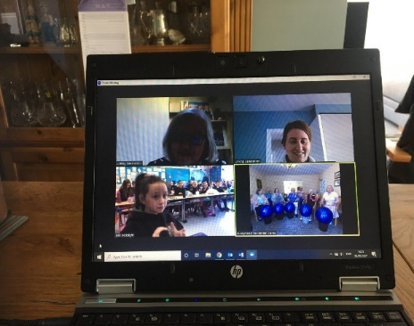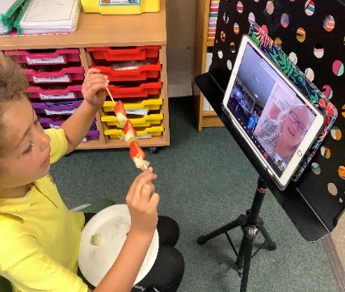
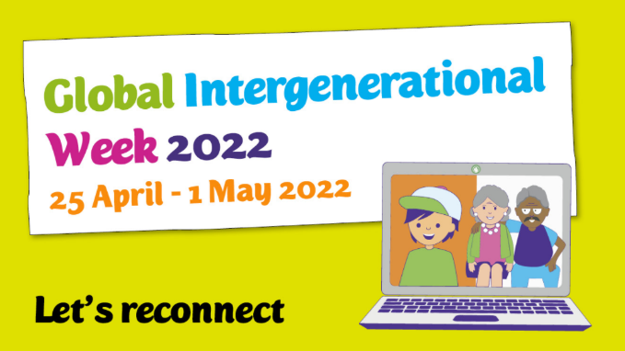
LGNI are excited for the upcoming Global Intergenerational Week 2022. We would love for small grant applicants to look at the themes of the week and try to include them in your activities.
Click link for more information:
Global IG Week.

LGNI Global Intergenerational Week 2022

