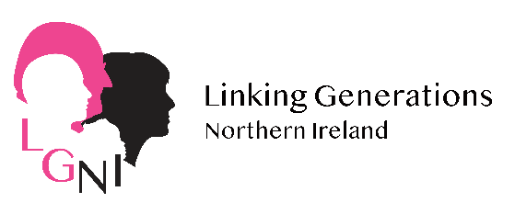
Connecting Care Homes and Communities Initiative

Intergenerational Training for staff
Are you interested in developing intergenerational connections but just aren't sure how to do it, need ideas and support to help you develop links? Linking Generations NI's 4.75 hour CPD accredited Intergenerational training is a great start.
LGNI are planning on running a bespoke training programme for Care Homes & Settings via Zoom and we would love to have you on board. If this sounds like something that you would like to take part in, please fill out the attached expression of interest form.
We can deliver training in 3 x 1.5 hour sessions, usually around lunchtime, to facilitate staff.
The sessions cover:
- What is Intergenerational practice?
- Good practice in preparing and bringing generations together (plus activity ideas for virtual and at a distance)
- Evaluation methods and sustainability

You will also receive our LGNI Intergenerational training manual, Care Home toolkit and Care Homes Good Practice ‘Do’s & Don’ts’ Guide to refer back to.

cost: £25 for 4.75 hours CPD accreditation

Check out our Linking Generations NI facebook page
website www.linkinggenerationsni.com
Click here to sign up to your local LGNI intergenerational network

Expression of Interest form
Contact Person’s Name & job title

Care Home name & address
Contact Phone numbers | Office:  Mobile:
Email

Please tell us below in a few sentences:
- A little bit about your Care Home
- Why you want to participate in intergenerational training and practice
- Where you consider you are in your intergenerational journey.

LGNI have lots of opportunities to get involved in intergenerational work via our local
Please return this form to Lynne.bennett@bjf.org.uk by 29.07.22

