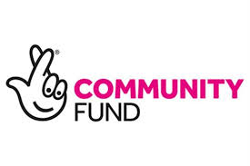

Intergenerational Small Grants
Christmas 2022 Get-Togethers
Application Pack

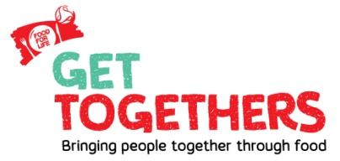

Small grants of £125 per group for events and activities to bring generations together through good food.

Please complete this application form and return to:
Joyce.Savage@bjf.org.uk
by
Friday, 28th October 2022 @ 12.00 noon

If you have queries please contact Joyce.Savage@bjf.org.uk

*Please refer to the guidance notes at the end of this form before you complete the application

Food for Life Christmas Get Togethers
Small Grants 2022
- Contact details

Name of group/organisation:

Council Area:

Name of contact person:

Address:

Telephone no: Mobile no:

Email address:
Does your group use social media? If yes please give Facebook / Twitter addresses below:

Facebook: Twitter:
(FYI we are Linking Generations NI on Facebook & @LinkGenNI on Twitter)

Website

- Tell us about your group e.g. what do you do? What geographic area do you cover? Have you done activities with people of different ages before?

- Your Get Together Idea:
3.1 Please tell us what you plan to do for your Food for Life Get Together, why you think it is important to bring generations together through food and what the benefits will be to all involved.
(Please use a separate page if necessary)

3.2 Approximately how many people will be involved in your project? (There should be at least 6- 8 of each age group)

Older People:
Younger People:

3.3 This funding is for activity during December 2022 -can you confirm this timescale is possible?
YES……. NO……..
3.4 Have you any existing partnerships that would benefit from this activity? e.g. how will you recruit participants? What preparation work do you need to do?

- Project Costs
Successful activities will receive a maximum grant of £125 in advance
(These grants are designed to support activities, not capital costs)

How much will the activity cost and what will you spend the money on? (Please note we would urge you to use existing resources where available)

Item / Activity | Amount needed
Total  (NB maximum available is £125 per project) | £

- Bank Details
Please give full bank account details of your organisation (please ensure these are accurate)
Bank Name: ...........................................................................................
Branch Address: ......................................................................................
Bank Account Name: .................................................................................

Sort Code:

Account Number:

- Organisation Governance Checklist
Please tick to confirm you organisation has the following governance arrangements currently in place
A signed and dated constitution or governing document ☐
A bank account in the name of your organisation ☐
Our accounts are annually audited ☐
A relevant child protection policy (for groups working with children under 18) ☐
Vulnerable adults policy where appropriate ☐

- Who will be responsible for the financial claims for this project?

Please sign your name below to confirm that the information provided in this form is correct and that you will be the person responsible for the grant
(We will accept electronic / typed signatures)

Name:

Position in the group:

Signature:

If you receive a grant all claims and receipts must be returned by
Monday 31st January 2023

Thank you for completing the application form to take part in Food for Life Christmas Get-Togethers
A panel will meet to choose the successful projects. The panel’s decision is final. Award of grants will be conditional on applicants signing a contract and payments made where possible by BACS
Our privacy policy is on our website; https://linkinggenerationsni.com/privacy-policy/
The information you supply will be held in the Linking Generations NI database; and will be used to inform you of future events, and any other relevant information. Your information will not be passed to a third party without your consent, unless required to do so by law.

Completed applications should be returned by 12.00 noon on Friday 28th October preferably by email to: Joyce.Savage@bjf.org.uk
or posted to:
Linking Generations Northern Ireland
43-45 Frances Street
Newtownards
BT23 7DX

**If you have sent us an application and have not received an acknowledgement of receipt within 7 days, please contact us to ensure that we have received your application successfully**
Guidance Notes
We will apply the following criteria to score the activity you have outlined in your application:
- Activities which use the principles of intergenerational practice and our good practice guide – please refer to our website for more detail:

www.linkinggenerationsni.com
Principles of intergenerational practice summary
- Mutually beneficial to both age groups
- Participants help to plan it
- Uses existing resources
- Well planned
- Locally connected
- Strengthens community
- Challenges ageism
- Connects organisations

- Activities that connect generations through food, conversation and activities during December 2022

- Activities which bring another generations in to an environment that is generally used by one generation only (eg schools, care homes, youth clubs, older people’s housing, services/organisations that usually work with just one age group)

- The promotion of healthy and nutritional food to make people feel good.

- Activities that are fun and involve all ages and that show good value for money

- Activities which engage older people who don’t get out much

- Activities that tackle loneliness and isolation for people of ALL ages

About Food for Life Get Togethers
A Food for Life Get Together is any event where different generations come together to grow, share or cook together. Food for Life Get Togethers are about people coming together and giving people of all ages and backgrounds a chance to connect while enjoying fresh, nourishing, healthy food.
This Food for Life Get Together grant is to support local people to connect with their community through cooking, growing and eating together. We are giving people of all ages and backgrounds the chance to get to know each other while sharing real, healthy food.
Today around 200,000 older people go over a month without chatting to a friend or family member. More than 9 million people often or always feel lonely, Food for Life Get Togethers are an opportunity to bring people together through food.
Food for Life Get Togethers funding aims to create connections across generations and organisations that wouldn’t normally work together. LGNI’s vision is that these connections and relationships will continue into the future.
Resources, Ideas and Support from our Partners
In Northern Ireland the Food for Life Get Togethers Project brings together partners including Food for Life, Linking Generations NI and The Big Lunch. We all have great resources and ideas to support your Food Get Together!
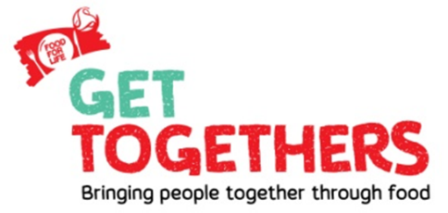
Sign up to the Food for Life Get Togethers network and access ideas & resources via
https://www.fflgettogethers.org/get-involved/sign-up/

Get some inspiration for your intergenerational activity, have a look at the Get Togethers Initiatives:
https://www.fflgettogethers.org/our-events/cook-and-share-month/
https://www.fflgettogethers.org/our-events/plant-and-share-month/
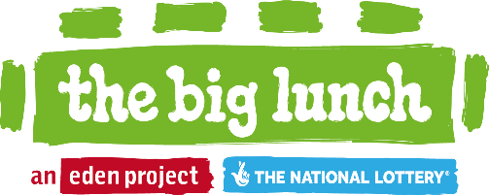
Sign up to the Big Lunch and receive a fantastic resource pack and lots of experienced help and ideas from others like you:
https://www.edenprojectcommunities.com/thebiglunchhomepage

Local support and network of people like you available here:
https://www.facebook.com/TheBigLunchNorthernIreland
LGNI Ideas and Support

Check out LGNI’s website for intergenerational ideas and sign up to your local intergenerational network
www.linkinggenerationsni.com/sign-up
Or engage with our Facebook page https://www.facebook.com/LinkGenNI/

Have a look at this short video of Get Togethers Activities funded grantees as part of our 2019 small grants scheme (pre Covid) https://youtu.be/Pb4s547IB0A

Virtual Get Togethers 2021 (using technology to link care home residents & school pupils) For more info on what took place check out: https://www.linkinggenerationsni.com/project/virtual-get-togethers-2021/

Check out our Virtual Get Togethers video https://youtu.be/zuKkWCy4oAE

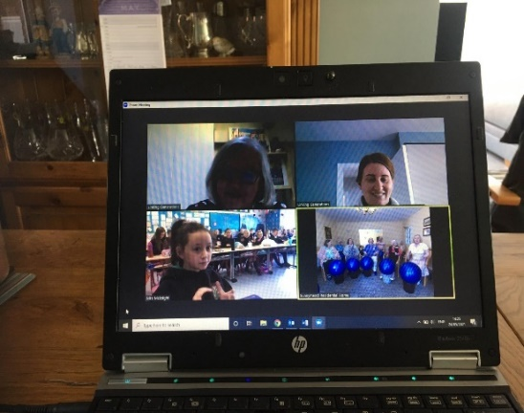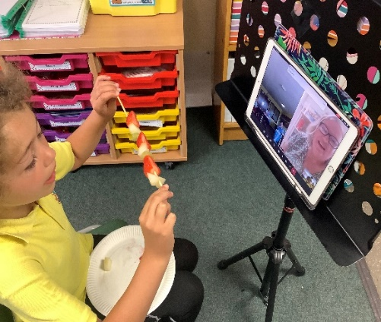
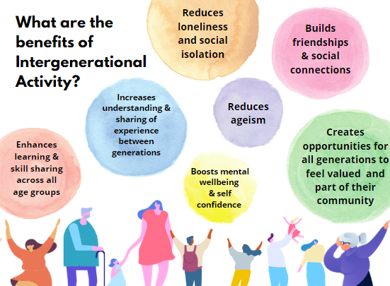

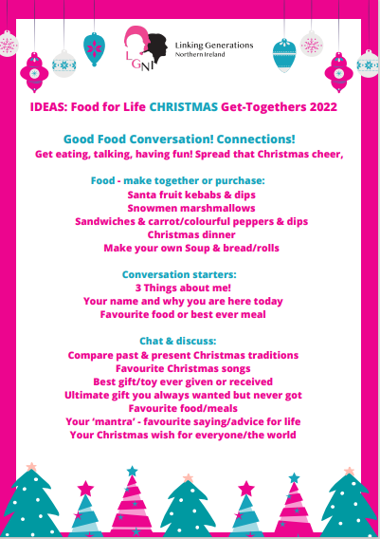

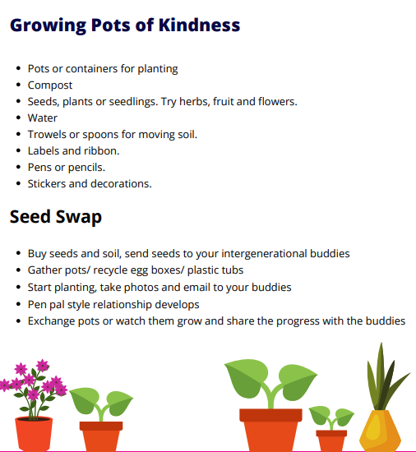

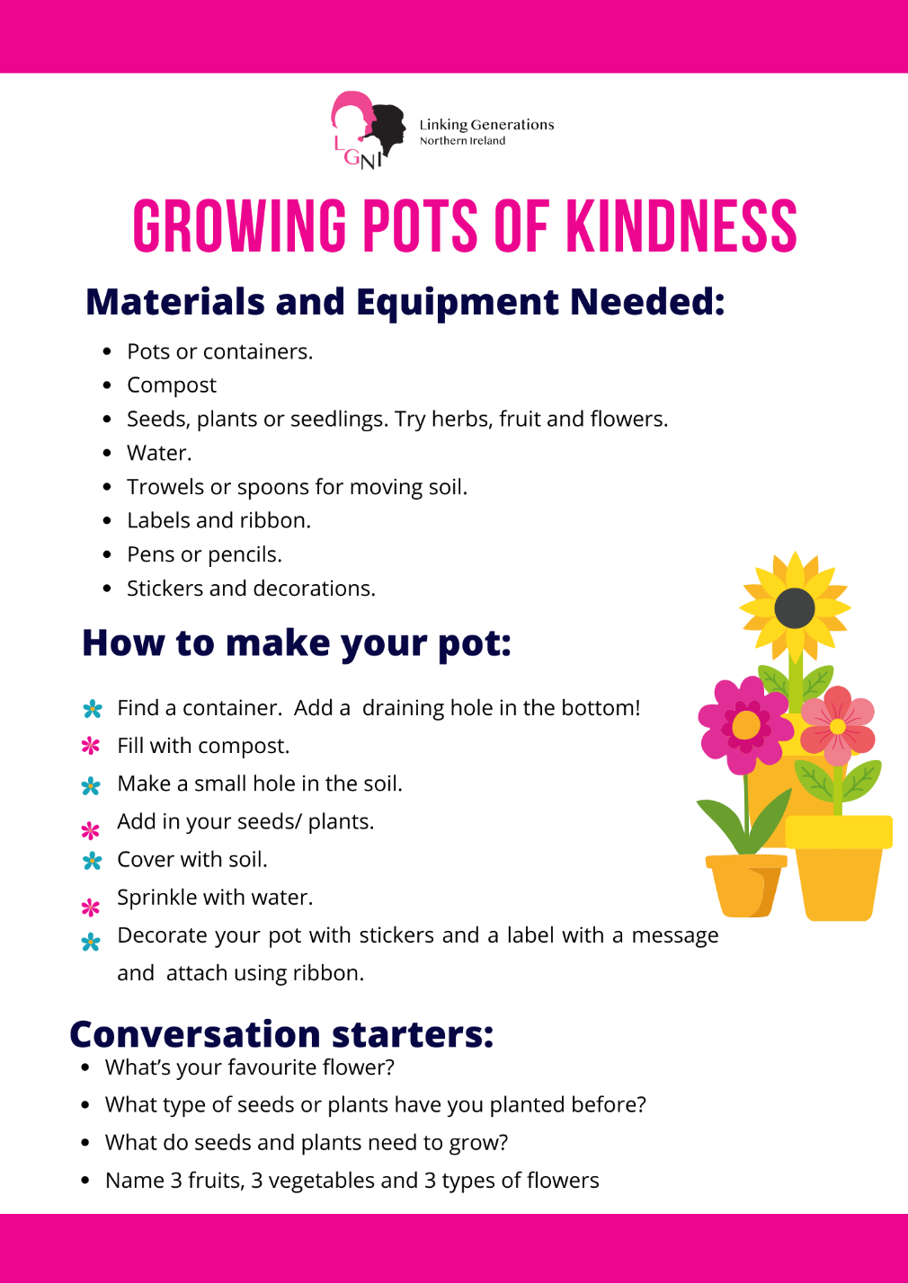

Contract for payment of funding: between you and LGNI.
Please read, sign and return to LGNI along with application
Friday 28th October @ 12.00 noon
If successful I (insert your name) ........................................ agree to the following as conditions for the receipt of £.............................(insert amount you applied for up to maximum of £125) from Linking Generations Northern Ireland for the Food for Life Christmas Get Togethers 2022
Conditions of grant
- If successful you will receive a successful applicant pack from LGNI and £125 grant will be released and paid by BACS in to the bank account details you have supplied
- You will register with the Food for Life Get Together Network https://www.fflgettogethers.org/get-involved/sign-up/
- You will adhere to the evaluation guidance in your successful applicant pack including providing photos and evaluation feedback (please ensure all photo permissions in place).
- All grant aid expenditure will be accounted for using the form supplied by LGNI – including originals or copies of all receipts/invoices by 31st January 2023
- Appropriate child protection and vulnerable adult procedures will be in place during activities.
- The project will be beneficial for all age groups and where possible, planned by all ages together.
- Publicity for, and recognition of the project will be sought locally. Reference will be made to Linking Generations Northern Ireland, The Lottery Community Fund, Food for Life Get Togethers and The Big Lunch where appropriate. Please contact us if you want these logos.
- You will return all evaluation and financial documentation to LGNI by 31st January 2023

Indicate the date, time and venue in for your Food for Life Get Together, so we can keep track of what’s happening and when.
Where
When
Time

Sign below to confirm your agreement with the above conditions and ensure a quick turnaround on funding provision if your application is successful!
Signed : ........................................ Name: ......................................................
On behalf of (name of organisation/group) :………………………………………
Thank you for your application and contract, good luck

Our Privacy Policy
Our privacy policy is on our website https://linkinggenerationsni.com/privacy-policy/
The information you supply will be held in the Linking Generations Northern Ireland database and will be used to inform you of future events and any other relevant information. Your information will not be passed to a third party without your consent, unless required to do so by law.

