Linking Generations Northern Ireland Candidate Information Pack for the post of:
LGNI Regional Development Worker
28 hours per week,
Salary £21,211 (FTE £27,271)
20 days (FTE 26 days) + Bank Holidays

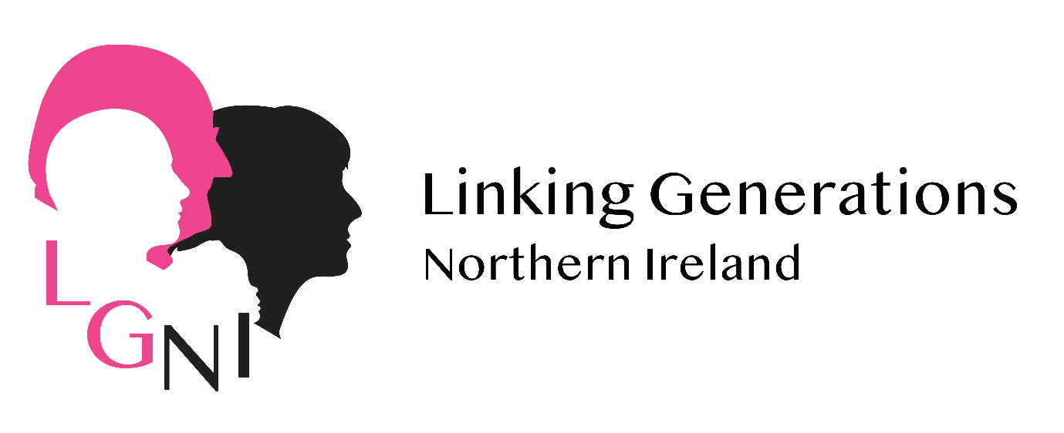
Completed Application Forms must be returned to vicki.titterington@bjf.org.uk by 5:00pm on
1st February 2022
(Provisional date for interviews 9th February)
Foreword from the LGNI Director
Dear Applicant,
Thank you for your interest in the post of Regional Development Worker with Linking Generations NI. I have been the Director of LGNI since its inception in 2009 and it is an exciting time as we move out of the Covid pandemic and have just been successful in accessing funding from The National Lottery Community Fund, working with lead partners Generations Working Together Scotland and Apples & Honey London. We are looking for an outstanding, creative, innovative and energetic person, who will passionately promote our vision and mission.
Linking Generations NI (LGNI) and our small passionate team act as the Northern Ireland Centre for Intergenerational excellence working at a grassroots, practice and policy level to expand high quality intergenerational practice. We have developed a range of highly professional, innovative and unique services which support our network membership and those interested in developing intergenerational approaches in the communities they live work and go to school.
We are a small organisation with big ideas and impact and are seeking an ambitious team member to support us to develop intergenerational practice across Northern Ireland at grassroots and policy level through the delivery of our key services (networking meetings, advice and support, training and resource development) and promotion of our key messages. The successful applicant will support the LGNI team to build new connections and relationships; grow our network membership; coordinate intergenerational meetings/events; develop and deliver intergenerational training; support the development of intergenerational activity and overall promote the importance of intergenerational practice across Northern Ireland.
This is an important position within LGNI and we are keen to recruit someone who is passionate about connecting people, thrives in a team but who can work on their own initiative. The successful candidate will be an LGNI ambassador upholding our strong reputation and promoting the value and impact of our work.
If you share our passion for bringing generations together across communities, organisations and settings in Northern Ireland, we would encourage you to apply for this position.
Yours sincerely,

Vicki Titterington

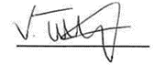

LGNI Director

Background on LGNI
Linking Generations Northern Ireland (LGNI) has been supporting communities to bring different generations together since 2009. LGNI is part of the Beth Johnson Foundation England who previously coordinated the UK Centre for Intergenerational Practice. As the only organisation solely focusing on the development and promotion of intergenerational approaches in Northern Ireland LGNI’s small but passionate team act as a catalyst organisation supporting people, organisations and communities to develop their own intergenerational initiatives.
LGNI use the Beth Johnson Foundation definition of intergenerational practice, aiming to bring people together in purposeful, mutually beneficial activities which promote greater understanding and respect between generations and contributes to building more cohesive communities.
LGNI inspire and support the growth of an Age-friendly society through connecting older and younger people and is the nationally recognised centre of excellence supporting the development and integration of intergenerational work across Northern Ireland. Our mission is to develop, expand and improve quality intergenerational practice.
LGNI coordinate a country wide community of practice through our 11 local intergenerational networks and membership of over 760 people, you can join by signing up here. We host regular network meetings and events to connect people and use our expertise to build intergenerational capacity within communities and organisations through the delivery of tailor-made projects, training programmes and the provision of advice and support. We also use our evidence to influence policy makers to recognise and support intergenerational approaches as a catalyst for social change. LGNI empower people to implement their own intergenerational solutions in the communities they live and work in check out our latest news for examples.
Our vision is that Northern Ireland will be a place where all generations are respected, understood, connected and engaged together in their communities. To achieve this LGNI offer opportunities to bring generations together in lots of different places for lots of different reasons.
LGNI’s current work themes are focussed on the areas of Age-friendly, Health & Social Care and Education. LGNI’s strategic objectives to progress intergenerational work in these areas include to:
- Create, develop & maintain intergenerational networks to develop and support intergenerational practice in each NI council;
- Promote and deliver small grants programmes & funding opportunities via networks;
- Develop and deliver a NI focused accredited/bespoke training programme and resources to support capacity building and learning within communities;
- Provide a NI Centre of excellence for intergenerational work: advice & support service, inspiration, resources for those wishing to engage in IG practice at all levels;
- Advocating and embedding intergenerational practice by influencing its inclusion and implantation in Age-friendly and community planning processes in every Council area in NI.
All of LGNI’s work is guided by the Principles of Intergenerational Practice, further information can be found here.
Although LGNI’s work activities predominantly take place in NI we work with partners from across the globe on exciting projects and campaigns including Global Intergenerational Week and the Food for Life Get Togethers Project.
The successful candidate for the post of Regional Development Worker will be a central member of the LGNI team and get involved in all areas of LGNI work.

Linking Generations NI - The Beth Johnson Foundation

Job Description
______________________________________________________________

Title: LGNI Regional Development Worker (Northern Ireland)

Department: Linking Generations Northern Ireland

Responsible to: LGNI Director (Northern Ireland)

Roles: Networking, development work, advice & support, facilitation

Place of work: Hybrid work model: Home, LGNI Office Newtownards on occasion & out in the community

Hours: 28 Hours per week

Salary: £21,211 (FTE £27,271) including employer pension contribution of 7.5%

Job Purpose: To contribute to the development, delivery and sustainability of the Northern Ireland Intergenerational Programme − Linking Generations Northern Ireland (LGNI) − in accordance with the delivery plans, targets and objectives.

Main Tasks
- Promote and uphold the values inherent in intergenerational Practice and LGNI
- Support the development and implementation of work activities that help achieve LGNI’s strategic objectives and work as an effective member of the delivery team
- To coordinate, maintain and support further the development of local intergenerational networks aligned with council area Age friendly alliances and community planning processes – including hosting of meetings themed to local need, promotion of networks sign up/participation to new members and information sharing and collaboration
- To assist and encourage schools, community groups and age specific settings to establish links and develop partnerships with public, private and voluntary organisations through which new partnership opportunities are developed
- To assist in the delivery of our face to face/zoom accredited training programme and contribute to its further development
- Support the planning and organisation of information sessions, network meetings, conferences and other activities/events which are in accordance with the delivery of the strategic objectives
- To support the development and delivery of intergenerational activity in schools, care settings and the wider community through advice & support and resource development
- Prepare and implement application processes and delivery plans for LGNI grants schemes and projects e.g. All Ages April
- To support and encourage councils to champion intergenerational work and deliver a coordinated approach throughout their area by embedding intergenerational practice within community plans and age friendly plans and assist in the development of resources to support this
- To support the LGNI team with fundraising including the development of funding proposals, promoting LGNI services to Government Depts and Councils and identifying potential funding partnerships
- To input information, news articles, updates etc. onto the LGNI website and social media platforms (Facebook, Twitter, Youtube, Instagram) including provision of case studies and stories for e bulletins with support from the LGNI team members
- Ensure partners/participants adhere to agreed procedures, including collecting baseline information and evaluation
- To collate evidence and feedback from all LGNI activities and report back findings to the evaluator and also Community planning and Age friendly partnerships
- Provide practical support and advice re intergenerational practice to a range of organisations/groups/individuals
- To liaise with and assist in the development of partnership working with relevant organisations across Northern Ireland as part of the overall LGNI delivery plan
- Prepare reports on LGNI work and manage budgets
- Assist the LGNI Director with ideas for funding proposals and planning for sustainability
- Assist the LGNI Team with ideas for campaigns, projects and promotion
- Represent LGNI at meetings, events and conferences
- Assist the LGNI Team with press releases and promoting LGNI work through the media
- Operate at all times in accordance with Beth Johnson Foundation policies and procedures
General
- To participate in supervision and appraisal processes
- To undertake training relevant to development in the post
- To operate at all times in accordance with BJF/LGNI’s policies
- To do all that is reasonably practicable to maintain a safe and healthy work environment within the services managed, ensuring that appropriate risk assessments are carried out and compliance with organisational and statutory requirements
- To undertake such other duties as may be reasonably required e.g. assist LGNI Director/Regional Development Workers in delivery of project activity or attend meetings on behalf of LGNI

The Beth Johnson Foundation
Linking Generations Northern Ireland

Person Specification: Regional Development Worker

Experience | Essential | Desirable | Measurement  I=Interview  A=Application
- Project work/development at community level | √ |  | AI
- Working in partnership, networking and developing contacts | √ |  | AI
- Preparation of project proposals and funding bids | √ |  | AI
- Completing monitoring reports | √ |  | AI
- Development of training courses (including resources) and delivery of training sessions | √ |  | AI
- Work with schools/education providers | √ |  | AI
Knowledge | Essential | Desirable | Measurement
- Intergenerational Practice |  | √ | AI
- Youth, age, community and education sector in NI | √ |  | AI
- Local government structures and agendas including Age friendly and community planning | √ |  | AI
- The NI education curriculum and links to intergenerational work |  | √
Skills and Attributes | Essential | Desirable | Measurement
- Excellent communication and interpersonal skills | √ |  | AI
- Excellent group work/facilitation skills | √ |  | AI
- Presentation skills | √ |  | AI
- Effective time management | √ |  | AI
- Build positive working relationships | √ |  | AI
- Relationship building with policy makers, funders and organisations |  | √ | AI
- Office based IT applications (Microsoft) | √ |  | AI
- Commitment to team work | √ |  | AI
- Work on own initiative | √ |  | AI
- Marketing, promotion and social media skills |  | √ | AI
Qualifications and Training | Essential | Desirable | Measurement
- 3rd Level relevant qualification |  | √ | A
Personal Values | Essential | Desirable | Measurement
- A commitment to fairness and diversity | √ |  | I
- Confidentiality | √ |  | I
General | Essential | Desirable | Measurement
- Full clean UK driving licence and access to a car | √ |  | A
- Ability to work flexible hours e.g. evenings | √ |  | I
- Prepared to travel | √ |  | I

